



Taget fra: <https://www.fi.se/sv/vara-register/blankningsregistret/emittent/?id=5493004YF5D7Z612Z822>

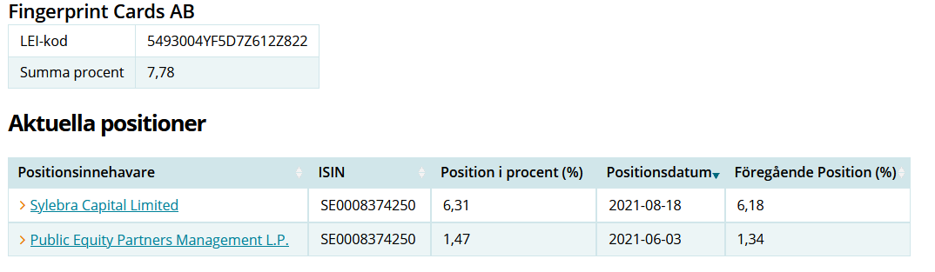

Og: <https://finance.yahoo.com/quote/FING-B.ST?p=FING-B.ST&.tsrc=fin-srch>